**PROGRESS REPORT II**

**OF**

**PERFORMANCE EVALUATING SYSTEM**

**FOR**

**TRANS-MERCH APPAREL (PVT) LTD**

**KADAWATHA**

**IMGT 3†34**

**Design & Development of Computer Based Project**

Submitted by

A.M.M.M.Abeysinghe

142033

First Supervisor: Ms.M.G.S.Dilanthi

Second Supervisor: Ms.J.M.N.M.Jayasinghe

Department of Industrial Management

Faculty of Applied Sciences

Wayamba University of Sri Lanka

Date of submission: 21st of August 2017

**ACKNOWLEDGEMENT**

IMGT 3+34 – Design & Development of Computer based Project is of significant importance for me as an undergraduate and there are many stakeholders who contributes towards completion of this project to whom I must extend my sincere thanks.

I convey my special thanks to my first supervisor Ms.M.G.S.Dilanthi for the invaluable supervision and guidance she affords me. I sincerely thank my second supervisor Ms.J.M.N.M.Jayasinghe for her continuous assistance in this regard.

My sincere gratitude is extended to Dr.A.D.Dharmawansa, for the great guidance offered by conducting the course modules which were of great support for the development of the system which is presented in this report.

I would also like to express my sincere gratitude to all the academic staff of the Department of Industrial Management, Faculty of applied Sciences of Wayamba University of Sri Lanka for their direct and indirect support toward the project.

I am highly gratitude to all the managers and non-managers in Trans-Merch Apparel (Pvt) Ltd for giving me the opportunity to analyze their existing system by providing valuable information with no hesitation whenever it was necessary.

I thank my colleagues and everyone who provided me with encouragement, support and guidance throughout this project.

**PREFACE**

This report is submitted in the partial fulfillment of the requirements for the Bachelor of Science (Joint Major/ Special) Degree Programme offered by the Department of Industrial Management of the Faculty of Applied Sciences of Wayamba University of Sri Lanka.

Through this report the functions of a Performance Evaluation System are identified. The study is based on an apparel manufacturing company, Trans-Merch Apperal (Pvt) Ltd, Kadawatha. The inefficiency and ineffectiveness of the existing system which is currently being operated manually is analysed and a system is proposed to eliminate the drawbacks and enhance the effectiveness.

This report includes an introduction of the organization, ER diagram and the graphical interface designs that I have created for the system. And further it contains normalized database structure and also the table previews and formats of reports that are going to be generated. This is a project report which provides an analysis of performance evaluation.

**CONTENTS**

1. INTRODUCTION 1

1.1 Scope of the System 1

2. SYSTEM DESIGN 2

2.1 Graphical User Interface (GUI) Design 2

2.1.1 Login 2

Figure 2: Main Menu 2

Figure 3: User Menu 3

Figure 4: User Registration 3

Figure 5: Change Password 4

Figure 6: Edit User 4

2.2.2.2 Employee Details 5

Figure 7: Employee Details Menu 5

Figure 8: Add Details 5

Figure 9: Search Employee Details 6

Figure 10: Remove Employee Details 6

2.2.2.3 Add Details 7

Figure 11: Add Details Menu 7

Figure 12: Cutting Department 7

Figure 13: Efficiency of other employees 8

Figure 14: Defect Rate of Other Employees 8

Figure 15: Attendance 9

Figure 16: Efficiency of Machine Operators 10

Figure 17: Defect Rate of Other Employees 11

Figure 18: Grading Machine Operators 11

Figure 19: Upgrading Machine Operators 12

Figure 20: Set Teams 12

2.2.2.4 Results 13

Figure 21: Results Menu 13

Figure 22: Overall Performance 13

Figure 23: Best Employee 14

3. DATABASE DESIGN 14

3.1 Entity Relationship Diagram 14

Figure 24: ER Diagram 15

3.2 Normalized Database Structure (3rd Normal Form) 16

3.3 Database Table Previews 17

3.4 Relational Schema 20

Figure 25: Relational Schema 21

4.1 Detailed Reports 22

4.1.1 Personal Details 22

Figure 26: Personal Details 22

4.1.2 Attendance Details 23

Figure 27: Attendance Details 23

4.1.3 Efficiency 24

Figure 28: Efficiency Details 24

Figure 29: Efficiency Details (Graph) 24

4.1.4 Defect Rate 25

Figure 30: Defect Rate 25

Figure 31: Defect Rate (Graph) 25

Figure 32: Efficiency 26

Figure 33: Efficiency (Graph) 26

4.2 Summarized Reports 27

4.2.1 Attendance 27

Figure 34: Attendance 27

4.2.2 Efficiency 27

Figure 35 : Efficiency 27

4.2.3 Damage Rate 28

Figure 36: Damage Rate 28

4.2.3 Employee Performance 28

Figure 37: Overall Performance 29

4.2.4 Employee Overall Performance 29

**LIST OF FIGURES**

Figure 1: Login 2

Figure 2: Main Menu 2

Figure 3: User Menu 3

Figure 4: User Registration 3

Figure 5: Change Password 4

Figure 6: Edit User 4

Figure 7: Employee Details Menu 5

Figure 8: Add Details 5

Figure 9: Search Employee Details 6

Figure 10: Remove Employee Details 6

Figure 11: Add Details Menu 7

Figure 12: Cutting Department 7

Figure 13: Efficiency of other employees 8

Figure 14: Defect Rate of Other Employees 8

Figure 15: Attendance 9

Figure 16: Efficiency of Machine Operators 10

Figure 17: Defect Rate of Other Employees 11

Figure 18: Grading Machine Operators 11

Figure 19: Upgrading Machine Operators 12

Figure 20: Set Teams 12

Figure 21: Results Menu 13

Figure 22: Overall Performance 13

Figure 23: Best Employee 14

Figure 24: ER Diagram 15

Figure 25: Relational Schema 21

Figure 26: Personal Details 22

Figure 27: Attendance Details 23

Figure 28: Efficiency Details 24

Figure 29: Efficiency Details (Graph) 24

Figure 30: Defect Rate 25

Figure 31: Defect Rate (Graph) 25

Figure 32: Efficiency 26

Figure 33: Efficiency (Graph) 26

Figure 34: Attendance 27

Figure 35 : Efficiency 27

Figure 36: Damage Rate 28

Figure 37: Overall Performance 29

**LIST OF TABLES**

Table 1: User Table 17

Table 2 : Department Table 17

Table 3: Designation Table 17

Table 4: Employee Detail Table 18

Table 5 : Attendance ID 18

Table 6 : Operation Table 19

Table 7 : Other Employee Efficiency Table 19

Table 8 : Machine Operator Efficiency Table 19

Table 9 : Defect Rate Table 20

Table 10 : Performance Table 20

# 1. INTRODUCTION

Trans-Merch Apparel Pvt Ltd was established in Toronto, Canada in 2006 as an apparel manufacturing and design company. They manufacture and distribute to all leading customers across North America. Furthermore they have strategic partnerships with Walmart, target, Sears and Bay Company. They own and operate manufacturing and distribution locations in Toronto, New York and Sri Lanka.

The Sri Lankan branch of Trans Merch Apparel pvt Ltd was established in Kadawatha in 2015.07.02. The current owner of the organization is Mr. Welayudan Ilangeshwaran Currently about 150 workers are working there under 3 managerial levels. They are specialized in knit garments including men’s, women’s and children’s t – shirts, polo shirts, fleece tops, polar fleece, intimate wear and essentials.

## 1.1 Scope of the System

From the whole business process, performance evaluation of the factory workers of Trans-Merch Apparel (Pvt) Ltd, is selected for this project. That is under the Human Resource Department of the company. Performance evaluation consists of following processes.

1. Handling efficiency details
2. Handling damage rate details
3. Handling attendance
4. Handling machine operator grading
5. Report generation

Currently most of the functions of the Human Resource Department of this company are done manually. The proposed system suggests a computer based process for current operation of performance evaluation to make the process more efficient and productive.

# 2. SYSTEM DESIGN

## 2.1 Graphical User Interface (GUI) Design

## 2.1.1 Login

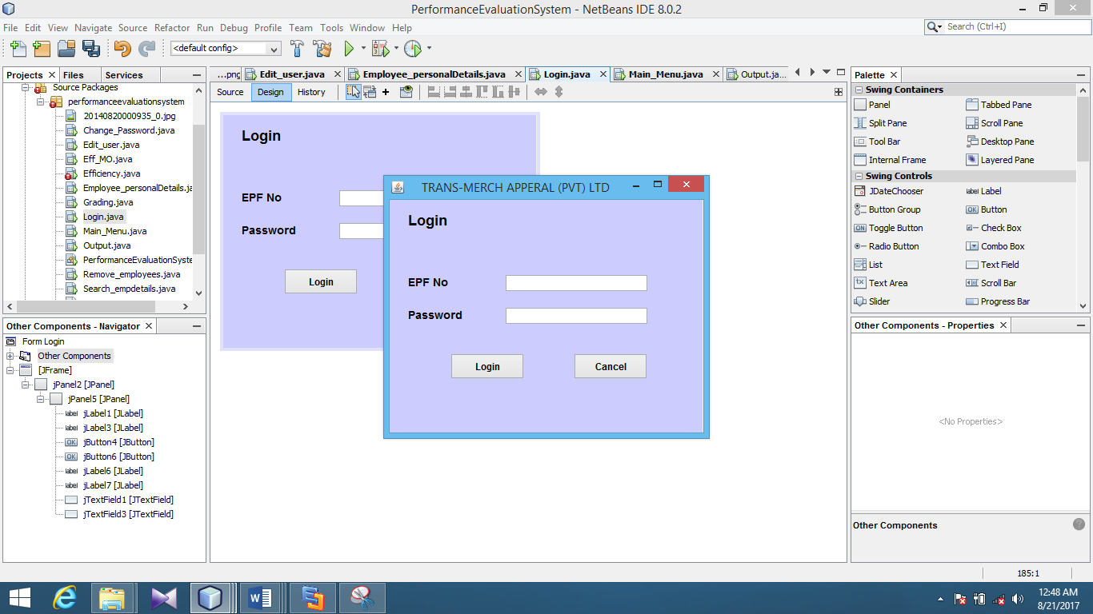This interface is used to allow different types of authorized users to log into the system. After adding their user name and password to relevant fields users can log into the system.

Figure 1: Login

**2.1.2 Main Menu**

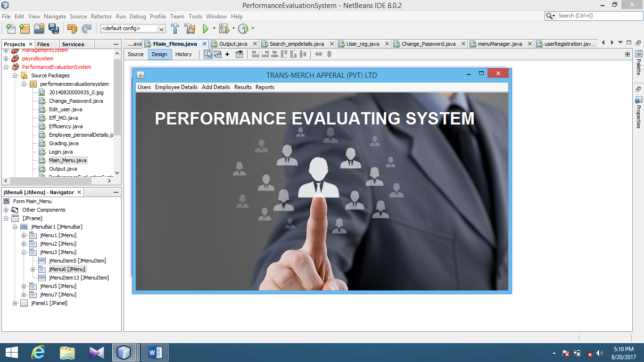This is the key interface of the system which guides the user to perform any functionality in the system.

Figure : Main Menu

***2.2.2.1 Users***

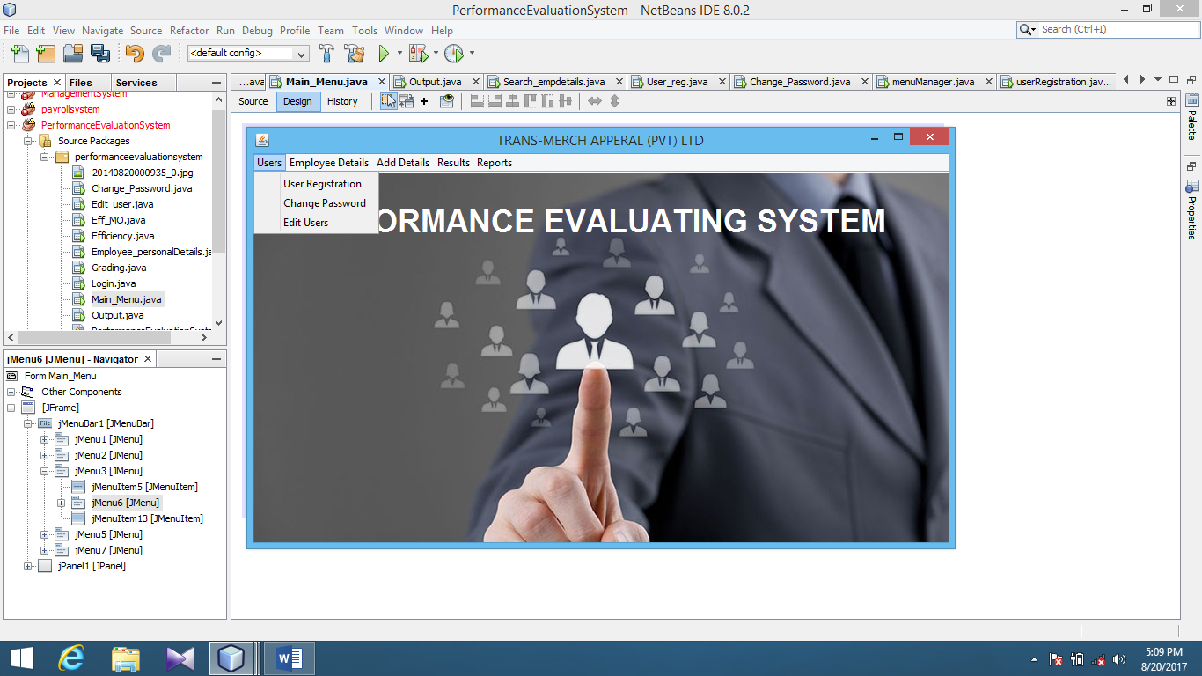This menu contains three sub menus for user registration, changing password and editing user as shown below.

Figure : User Menu

***2.2.2.1.3 User Registration***

This menu is used for registering new users according to their designation.

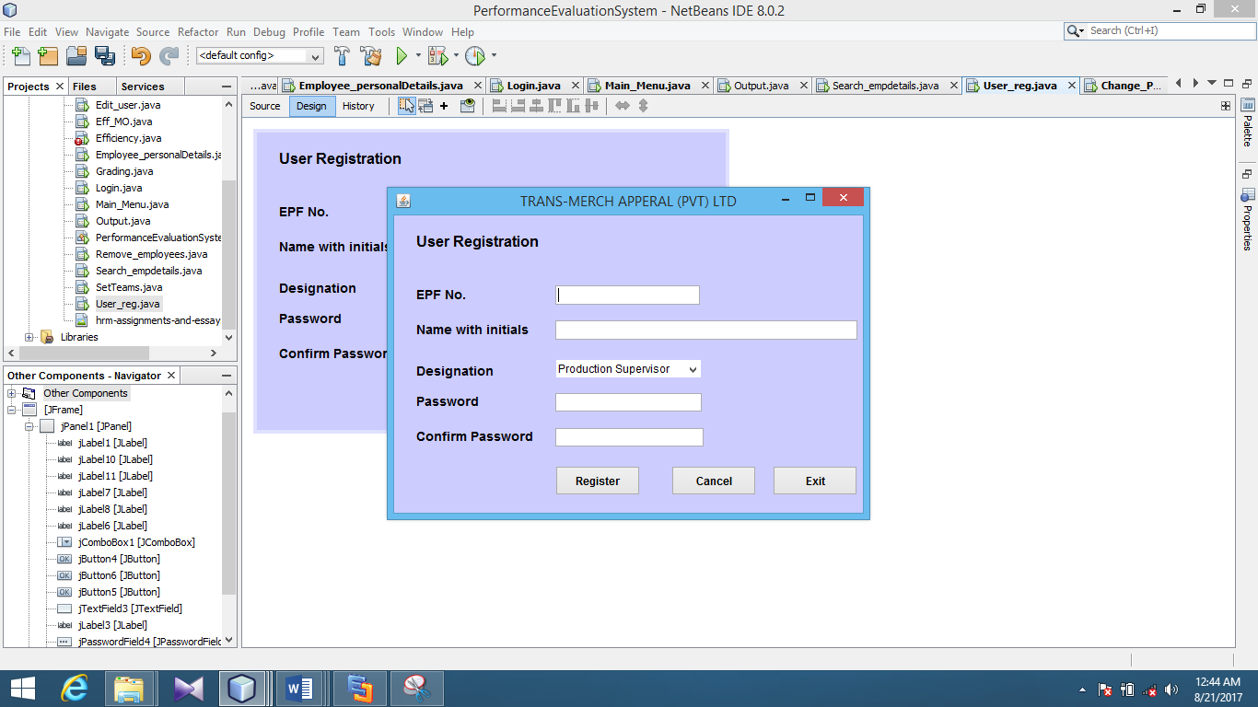

Figure : User Registration

***2.2.2.1.4 Change password***

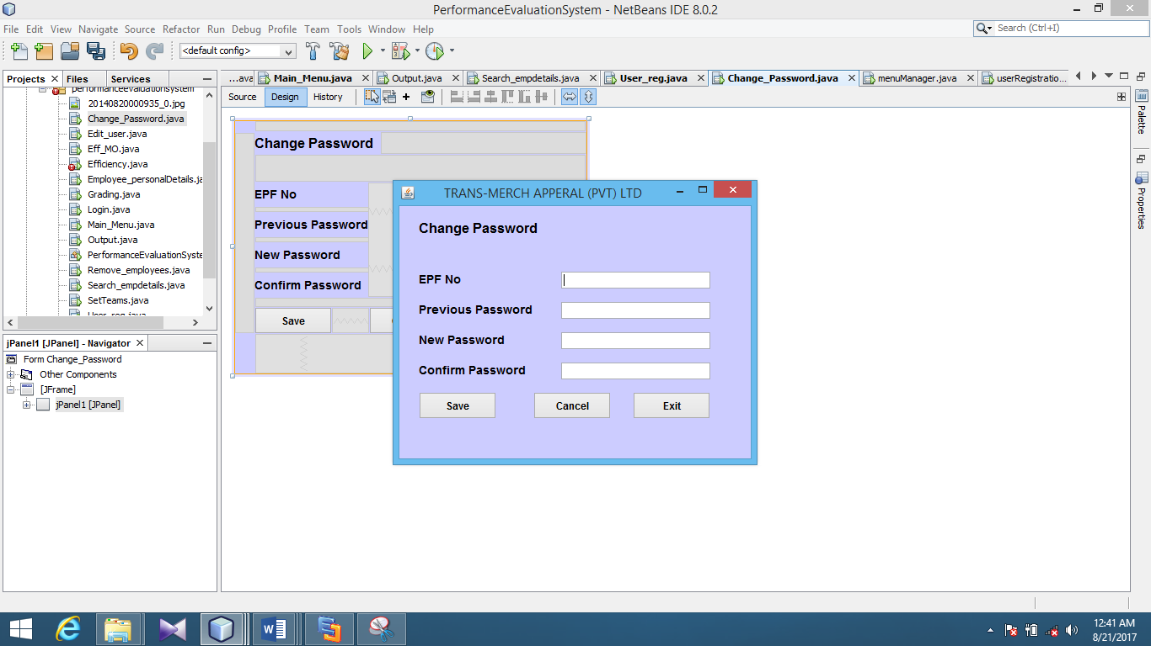Current users of the system can change their passwords whenever needed by using this interface.

Figure : Change Password

***2.2.2.1.3 Edit Users***

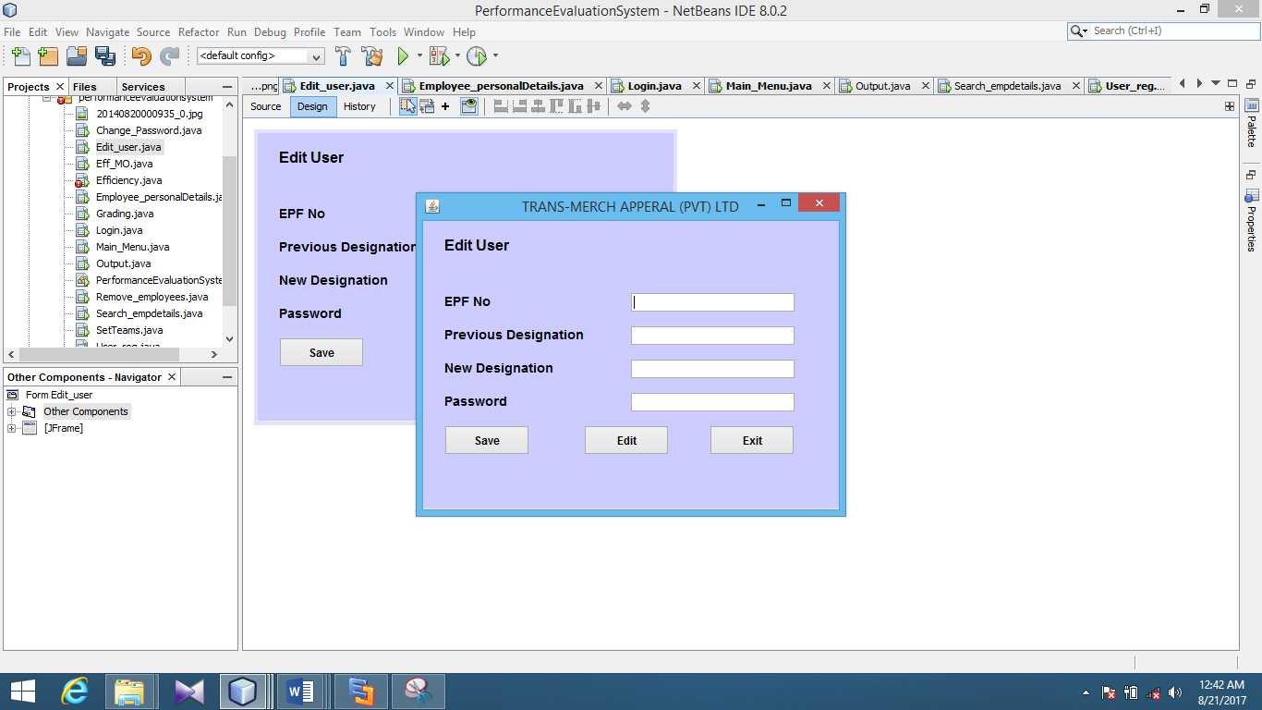When the current employees get promoted or demoted their designations are needed to be changed since only a limited number of designations have the access to the system. This interface is used for that purpose.

Figure : Edit User

### 2.2.2.2 Employee Details

This menu contains three sub menus for adding, searching and removing employee details.

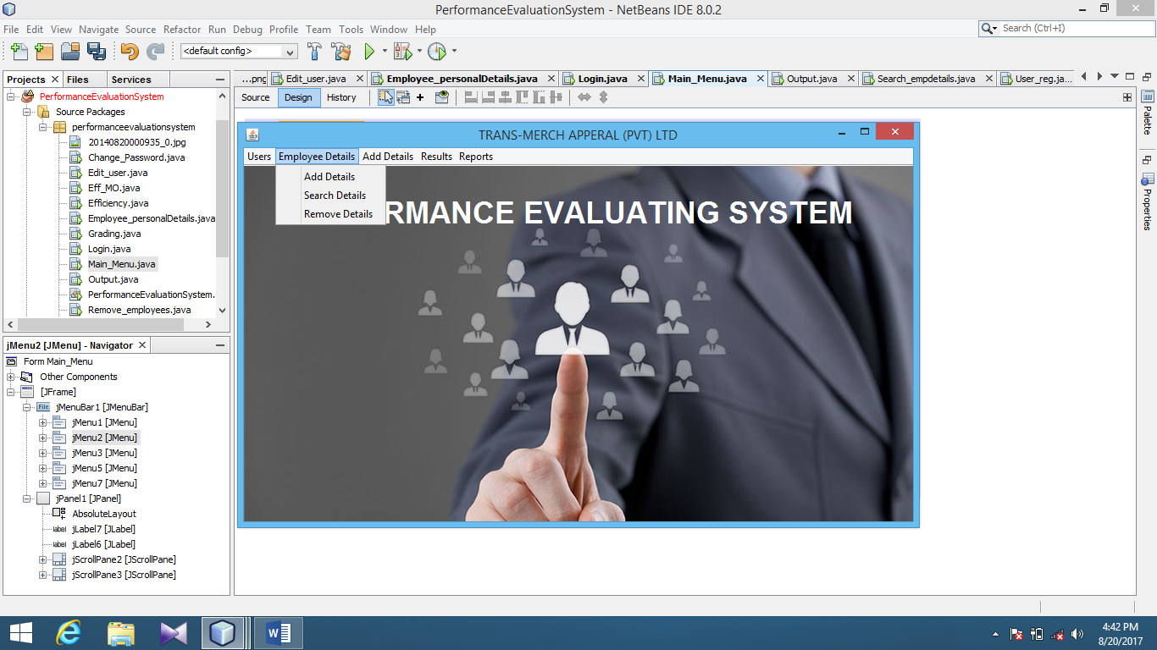

Figure : Employee Details Menu

#### 2.2.2.2.1 Add Details

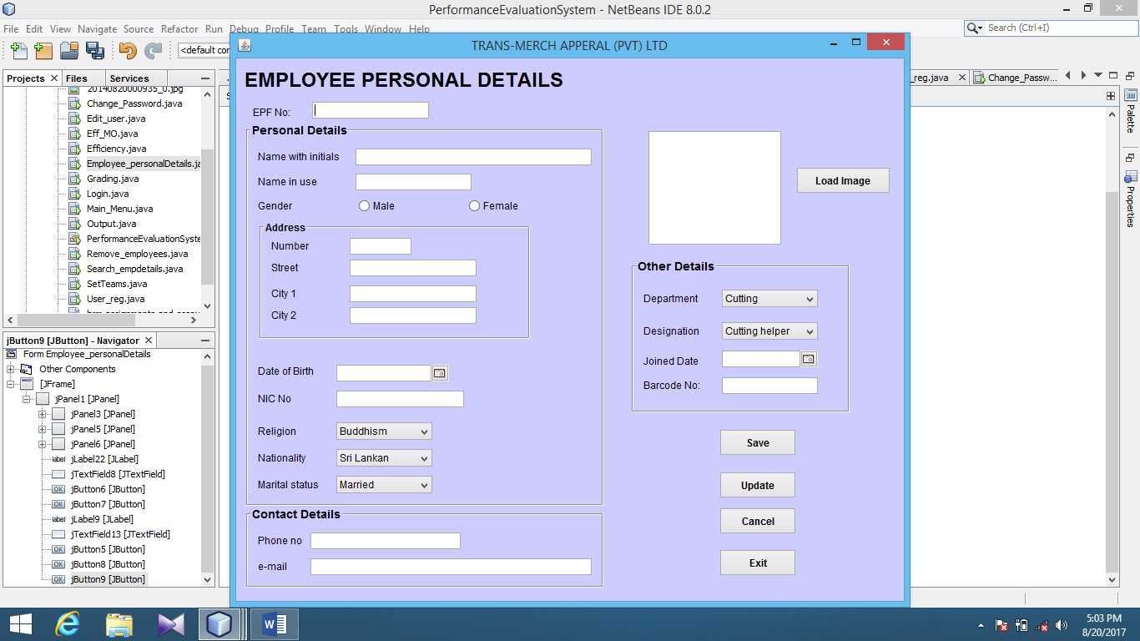This interface is used to add employee personal details.

Figure : Add Details

#### 2.2.2.2.2 Search Details

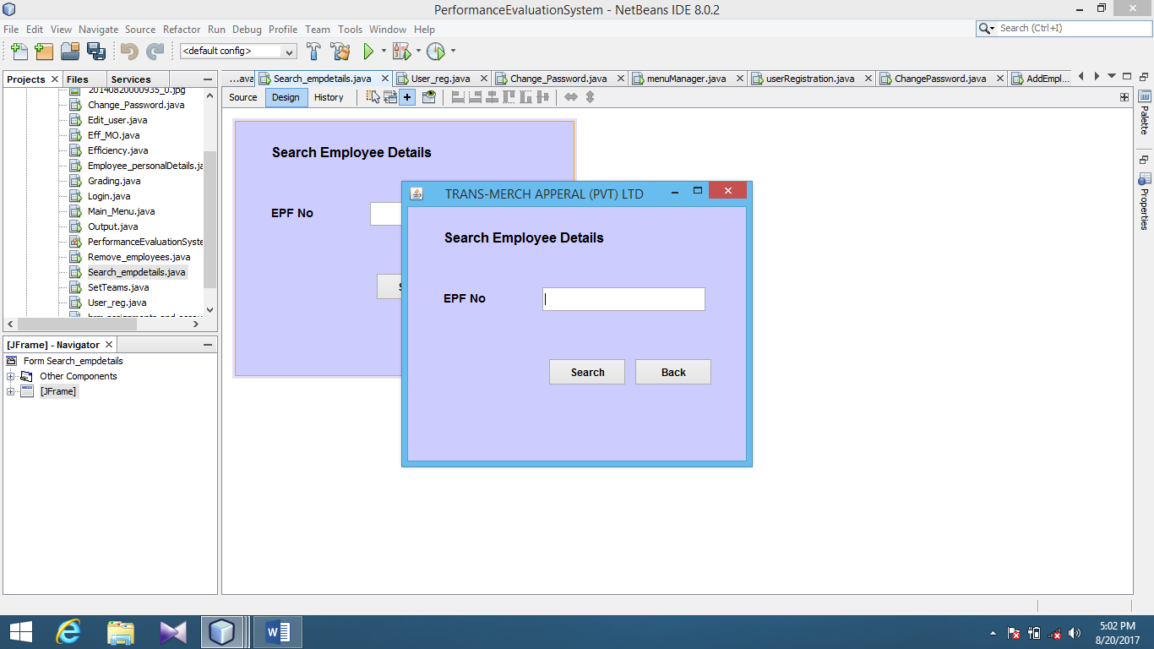This interface is used for searching employee details by providing their EPF number.

Figure : Search Employee Details

#### 2.2.2.2.3 Remove Details

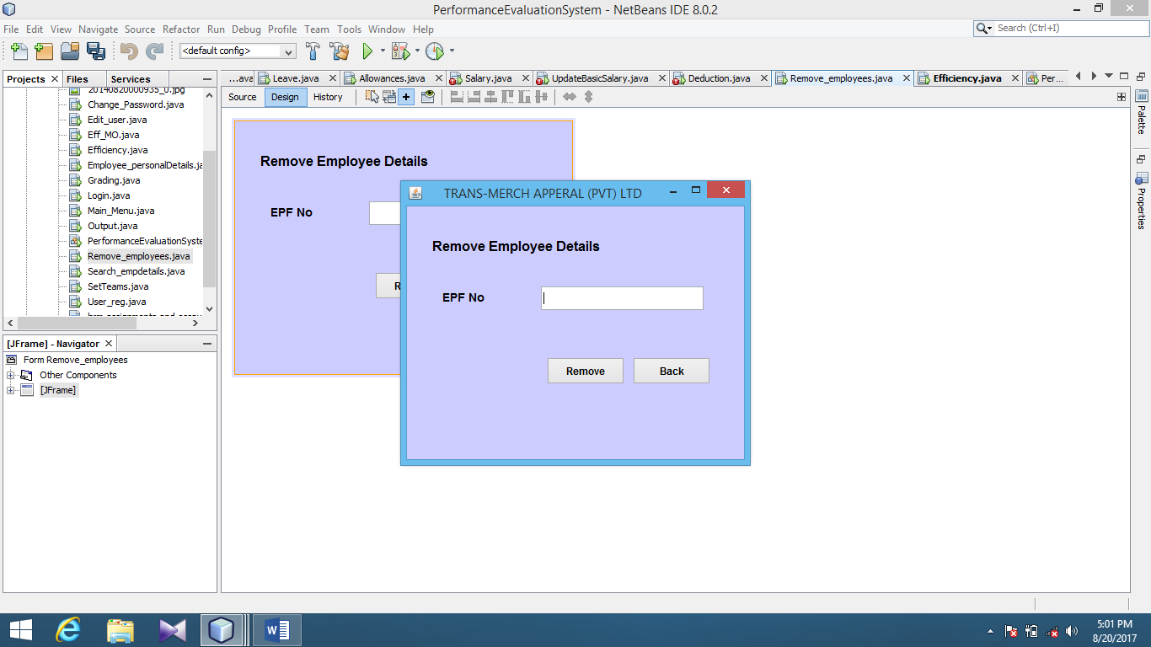When the employees are resigned from their job it is needed to remove their d details. This interface is used for that purpose.

Figure : Remove Employee Details

### 2.2.2.3 Add Details

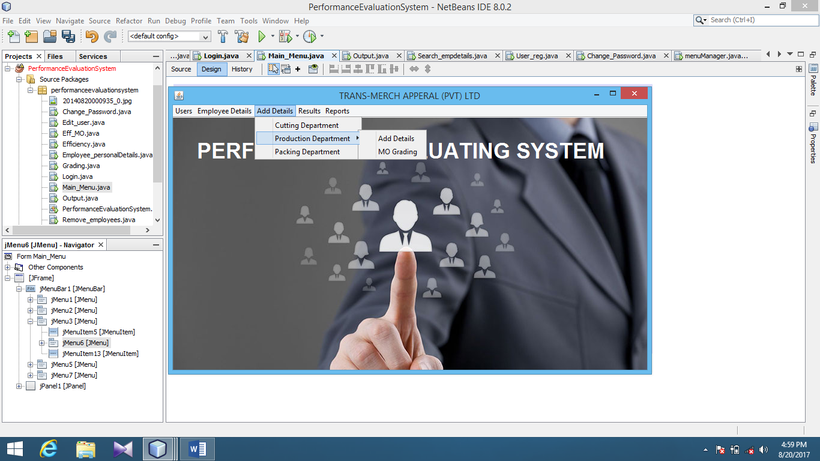This menu is used for adding employee performance details according to their department.

Figure : Add Details Menu

#### 2.2.2.3.2Cutting Department

This menu is used for adding efficiency details, damage percentage and attendance details of the cutters and cutting helpers of the Cutting Department.



Figure : Cutting Department

#### 2.2.2.3.1.1 Efficiency

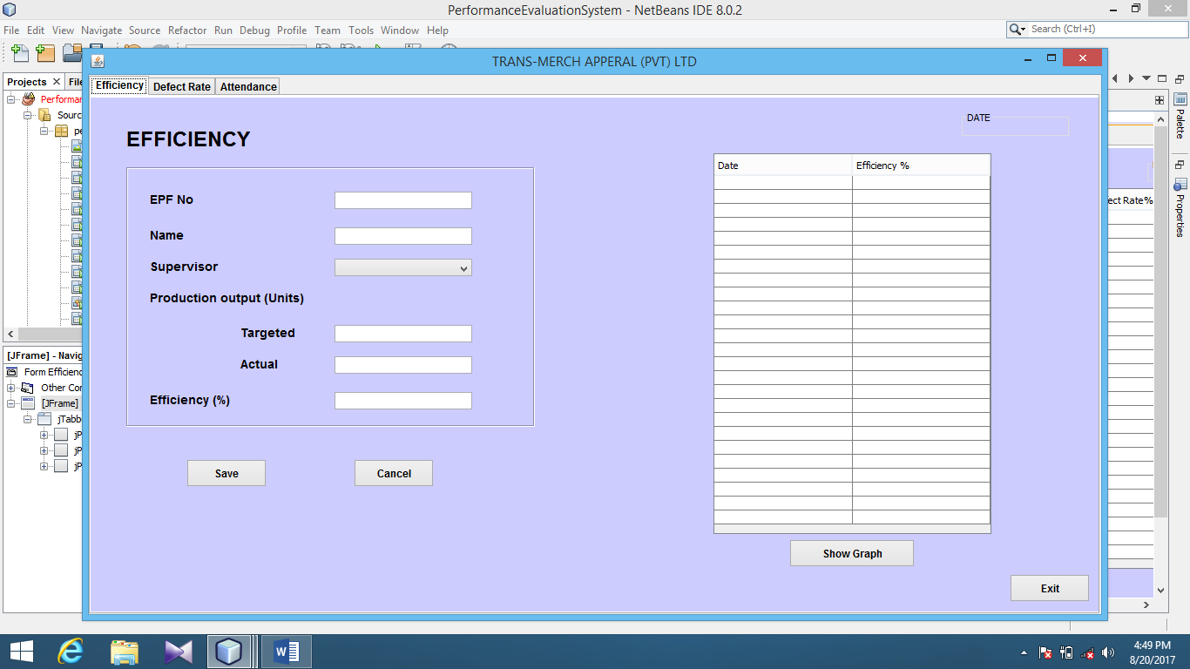This interface is used for recording the details relevant for the efficiency of the workers of the Cutting Department.

Figure : Efficiency of other employees

#### 2.2.2.3.1.2 Defect Rate

This interface is used for recording the details relevant for the defect rates of the workers of the Cutting Department. Furthermore it is useful for determining the quality of their work.

Figure : Defect Rate of Other Employees

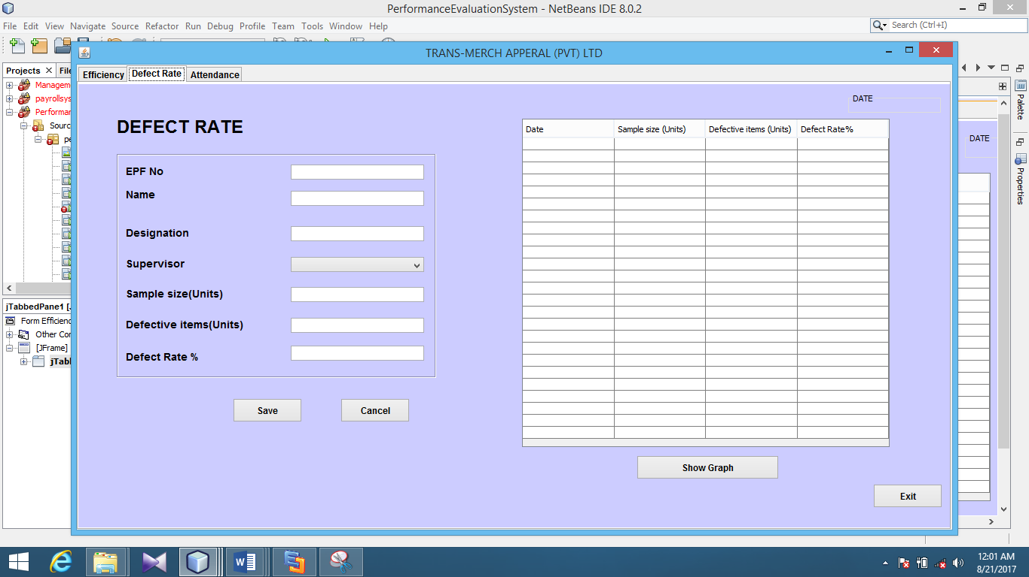

#### 2.2.2.3.1.3 Attendance

This interface is used for saving the details relevant for the attendance of the workers of the Cutting Department.

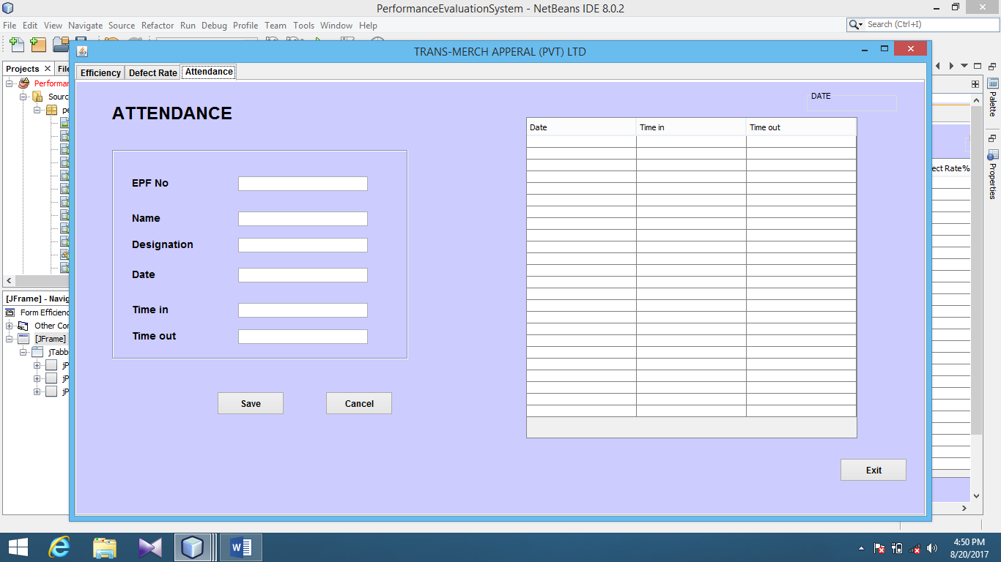

Figure : Attendance

#### 2.2.2.3.2 Production Department

This menu is used for adding efficiency details, damage percentage and attendance details of the machine operators and their helpers of the Production Department.

**2.2.2.3.2.1 Efficiency**

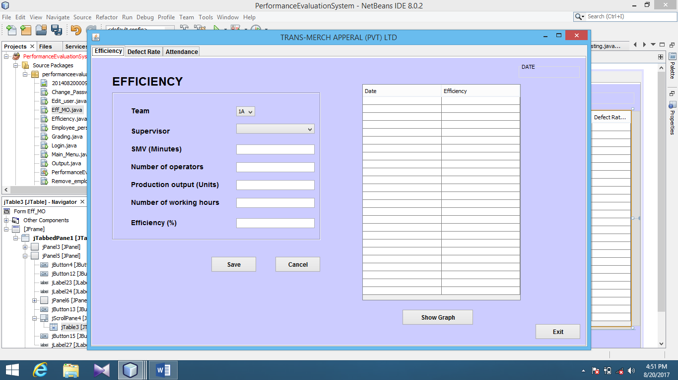This interface is used for recording the details relevant for the efficiency of the workers of the Production Department. Since there is a large number of machine operators and helpers their efficiency is calculated according to their team.

Figure : Efficiency of Machine Operators

#### 2.2.2.3.2.2 Defect Rate

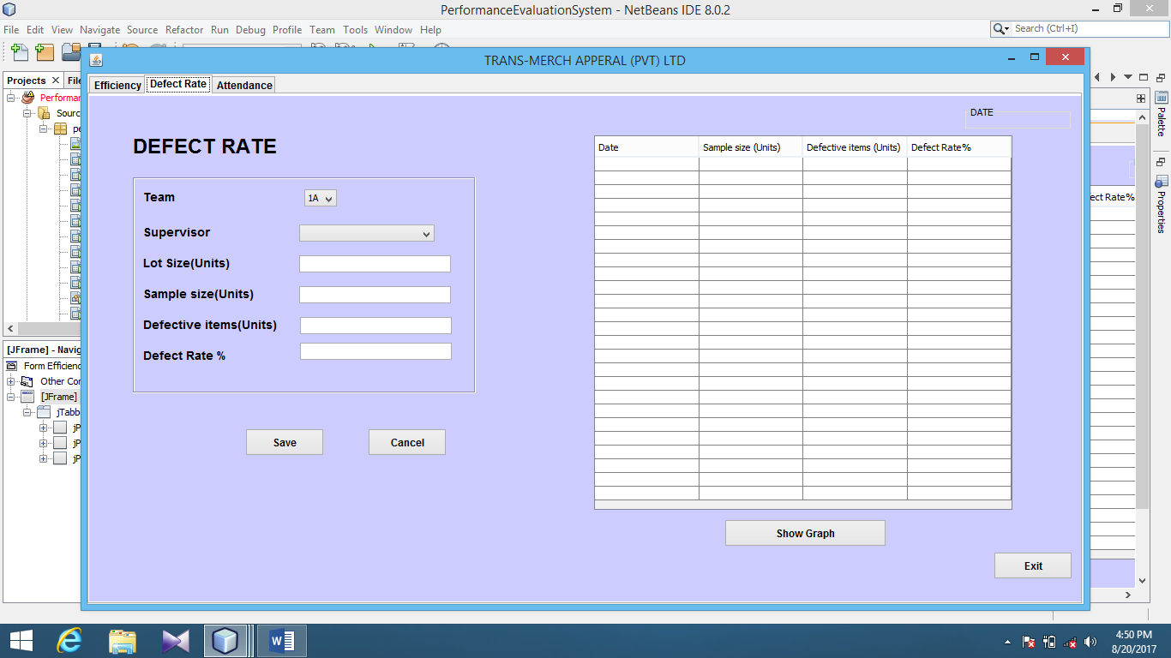This interface is used for recording the details relevant for the defect rate of the workers of the Production Department. It is useful for determining the quality of their work.

Figure : Defect Rate of Other Employees

#### 2.2.2.3.2.3 Grading Machine Operators

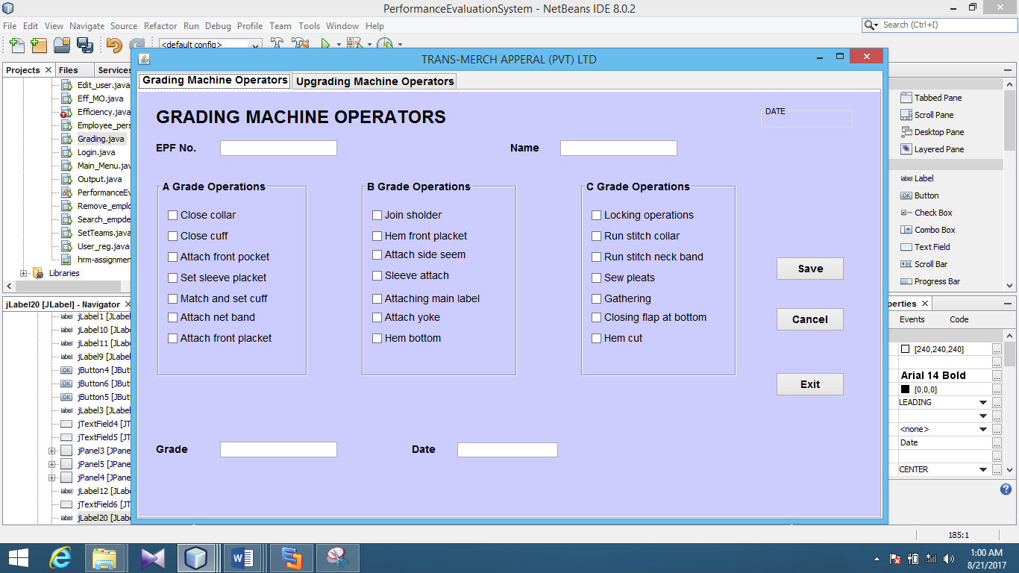Machine operators are graded according to their operation capabilities. This interface is used for that purpose.

Figure : Grading Machine Operators

#### 2.2.2.3.2.4 Upgrading Machine Operators

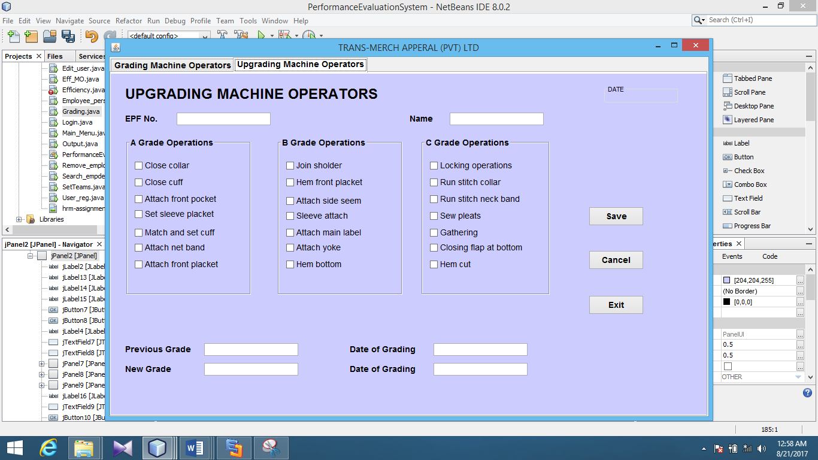This interface is used for upgrading machine operators.

Figure : Upgrading Machine Operators

*2.2.2.3.2.5 Set Teams*

This interface is used for uploading the information about the teams which are arranged by the Planning Department according to their capabilities.

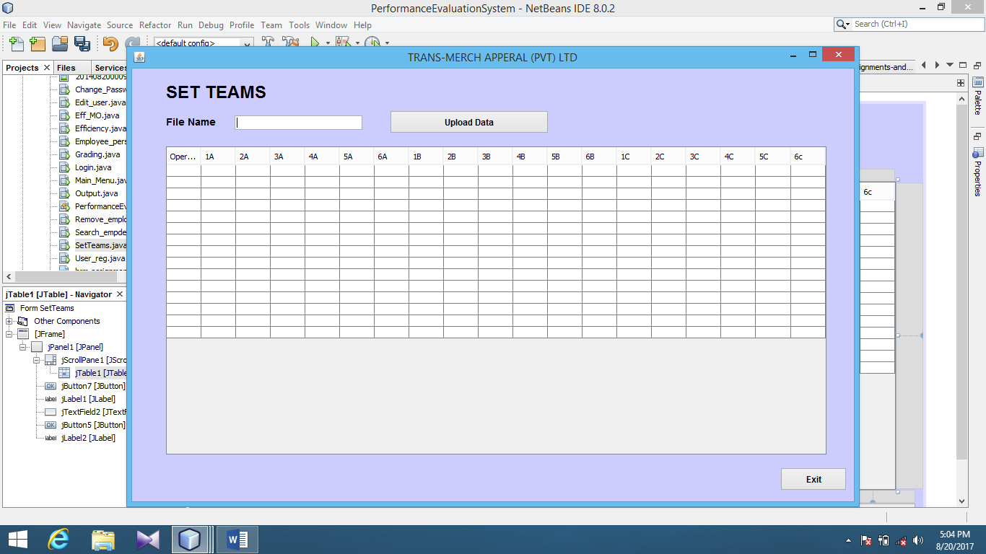

Figure : Set Teams

### 2.2.2.4 Results

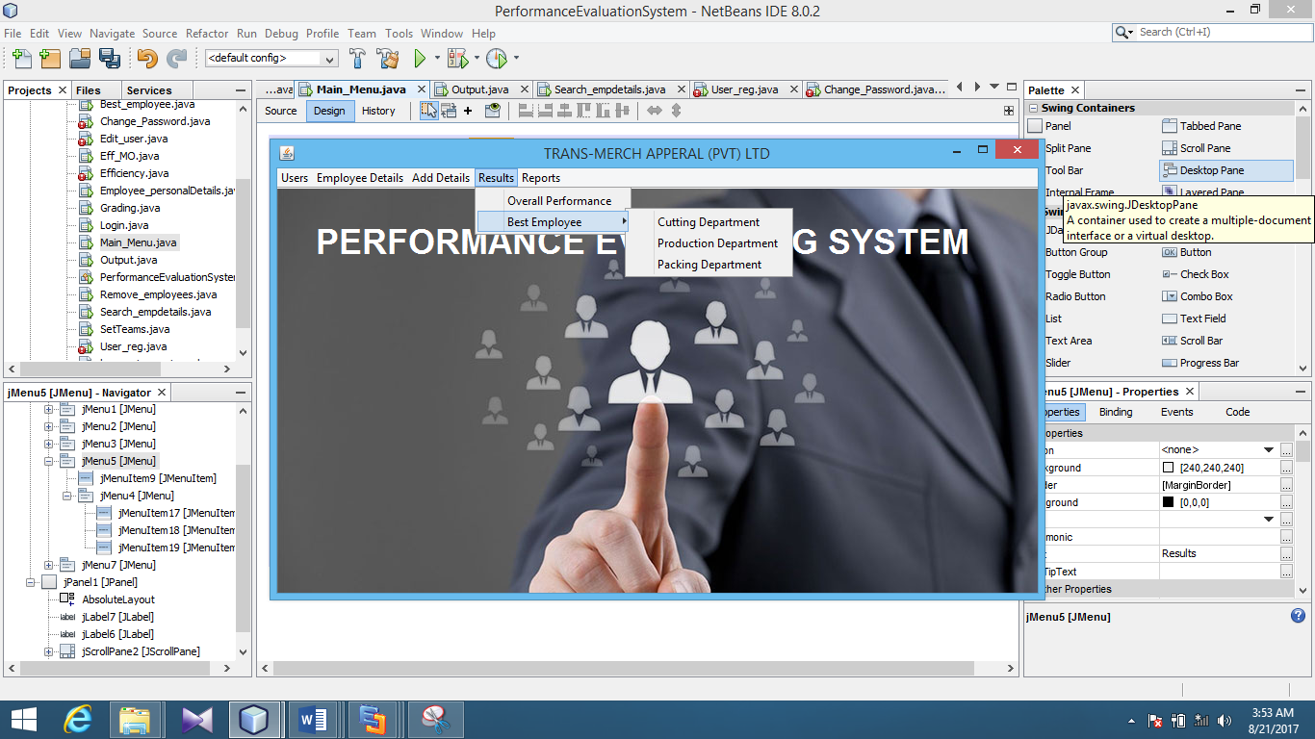This menu is used for the purpose of representing the results of the performance evaluation.

Figure : Results Menu

#### 2.2.2.4.1 Overall Performance

This interface is used for evaluating the overall performance of an employee.

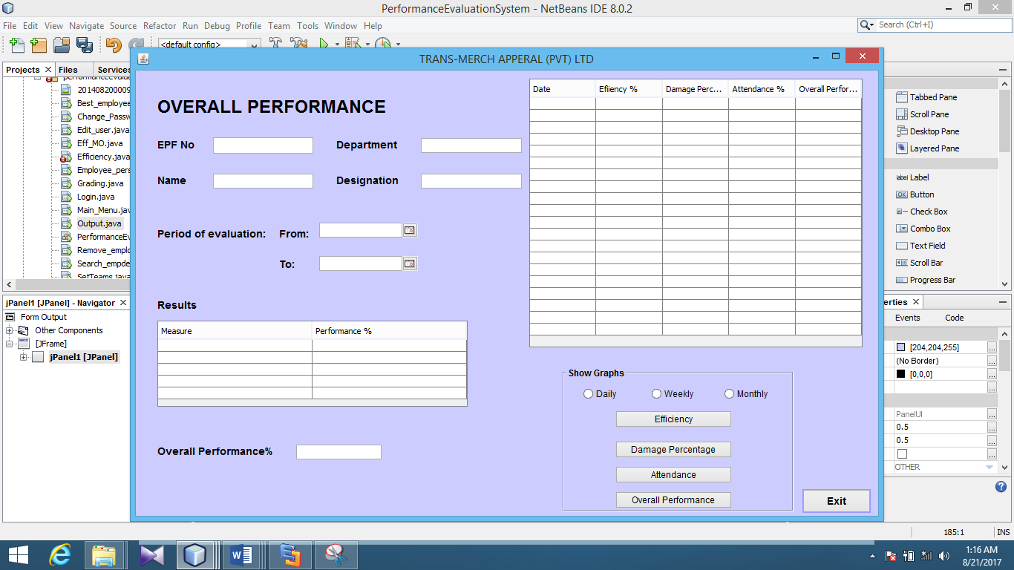

Figure : Overall Performance

#### 2.2.2.4.1 Best Employee

This menu is used for selecting the best employee within a certain period according to their department.

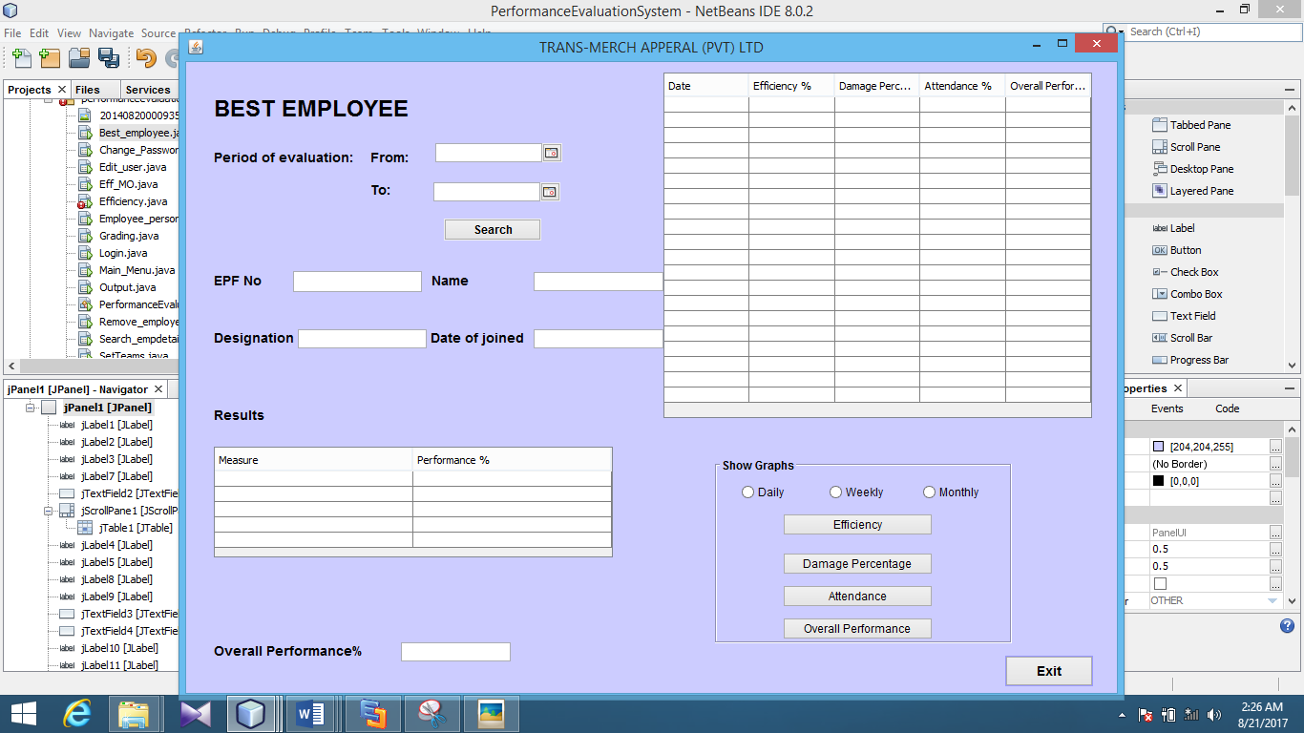

Figure : Best Employee

# 3. DATABASE DESIGN

## 3.1 Entity Relationship Diagram

In entity-relationship diagram, Entities are shown as points, polygons, circles, or ovals. Relationships are shown as lines connecting the points, polygons, circles, or ovals. ER diagram has an equivalent relational table, and any relational table has an equivalent ER diagram.

ER diagramming is an important to engineers in the design, optimization.

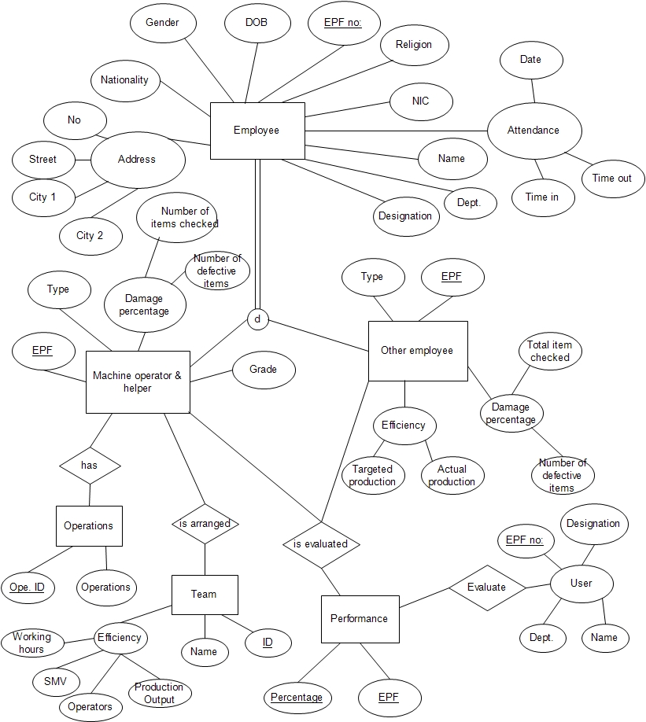

Figure : ER Diagram

3.2 Normalized Database Structure (3rd Normal Form)

* Composite and non-prime attributes of the tables are decomposed. Therefore the first normal form is acquired.
* All the non-prime attributes of the relations are dependent completely on the full key; the tables are in the second normal form.
* Transitive dependencies of all tables have been removed and normalized into the third normal form.
* The primary keys and the foreign keys are marked according to the standard structure.

The normalized tables are as follows.

* Employee (EPF No, Name with initials, Name in use, Number, Street, City 1, City 2, Gender, Religion, DOB, Nationality, Marital Status, Phone no. e-mail, Dept_ID, Designation_ID)
* Department (Dept_ID,Department)
* Designation (Desg_ID,Type)
* User (EPF No,Name)
* Operation (Operation_ID,Operation,Grade)
* Attendance (EPF No, Date, Time in, Time out)
* Efficiency_other (EPF No, Targeted output, Actual output, Efficiency)
* Efficiency_MO (Team_ID, Name, SMV, Number of operators, Production output, Number of working hours, Efficiency)
* DefectRate_O(EPF No, Sample size, Defective items, Defect rate, Dept_ID,Desg_ID)
* DefectRate_MO(TeamID,Sample size, Defective items, Defect rate, Dept_ID,Desg_ID)
* Performancedetails(EPF No, Percentage)

## 3.3 Database Table Previews

Table : User Table

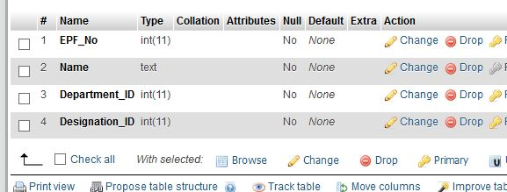

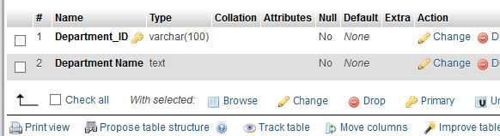

Table : Department Table

Table : Designation Table

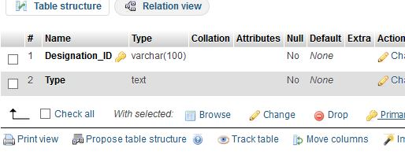

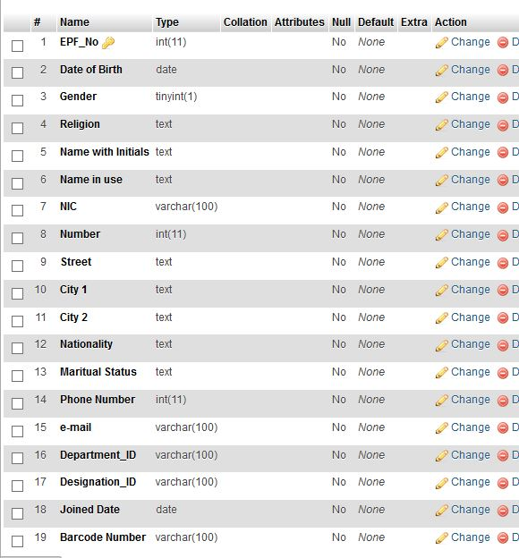

Table : Employee Detail Table

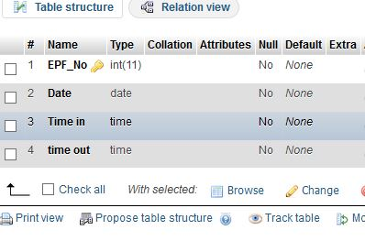

Table : Attendance ID

Table : Operation Table

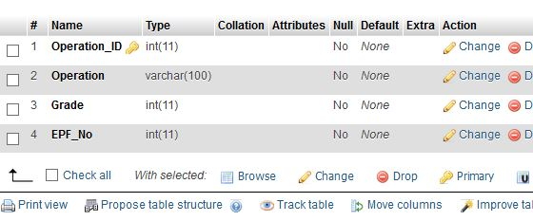

Table : Other Employee Efficiency Table

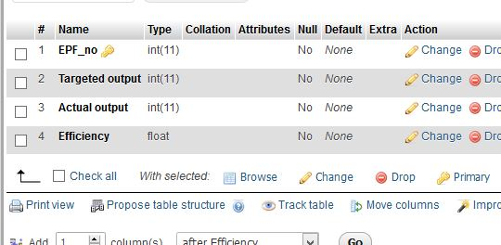

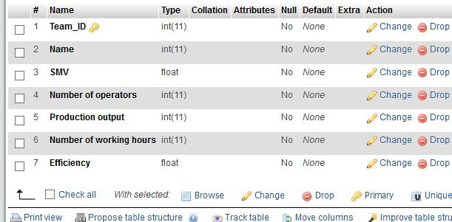

Table : Machine Operator Efficiency Table

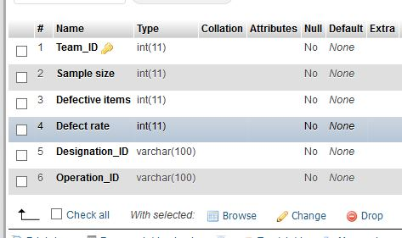

Table : Defect Rate Table

Table : Performance Table

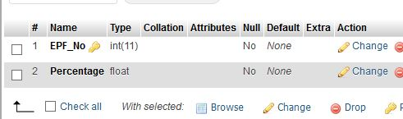

## 3.4 Relational Schema

The relationships of above mentioned tables are shown under the Enhanced Entity Relationship diagram.

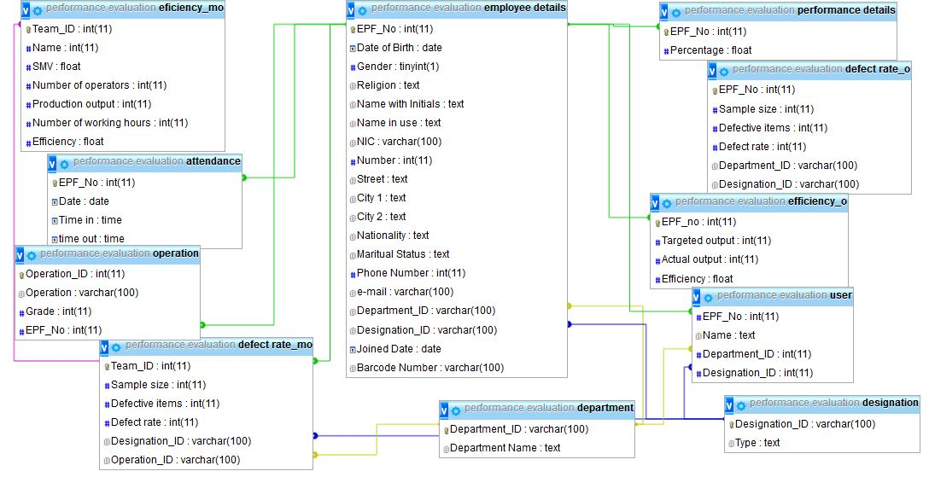

Figure : Relational Schema

# 4. FORMATS OF REPORTS

Two types of reports are generated in this system. They are detailed reports and summarized reports. Furthermore these data are represented graphically for the easy understand of the users.

## 4.1 Detailed Reports

There are several types of detailed reports as shown below.

### 4.1.1 Personal Details

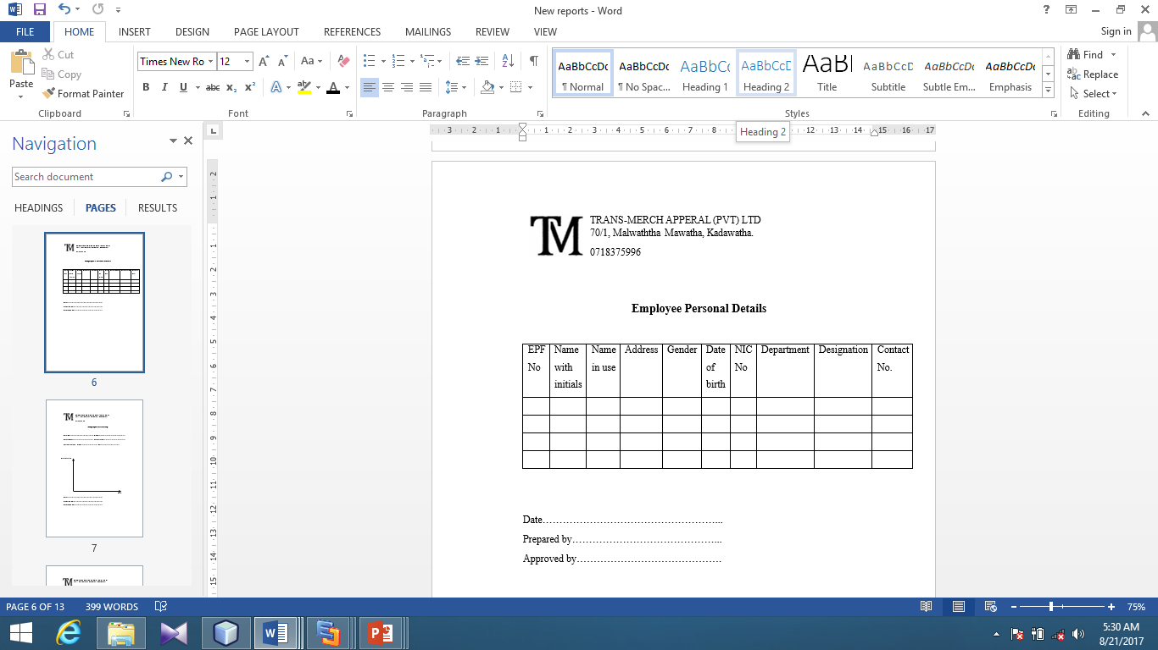

Figure : Personal Details

### 4.1.2 Attendance Details

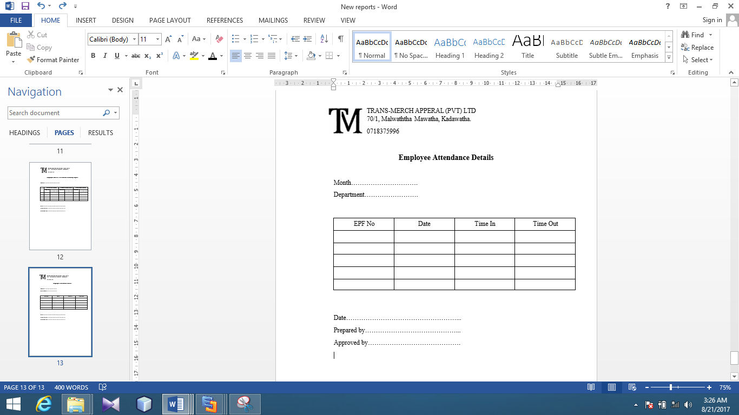

Figure : Attendance Details

### 4.1.3 Efficiency

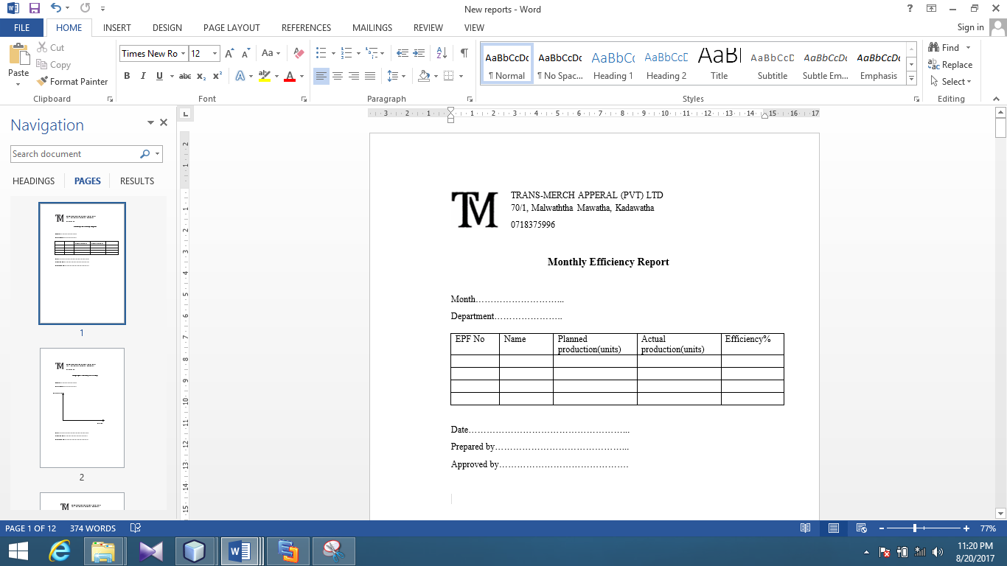

Figure : Efficiency Details

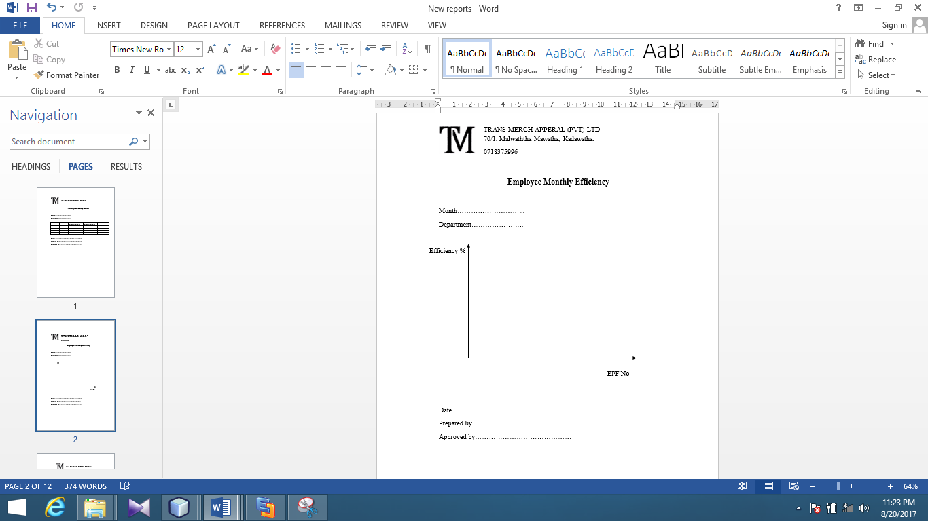

Figure : Efficiency Details (Graph)

### 4.1.4 Defect Rate

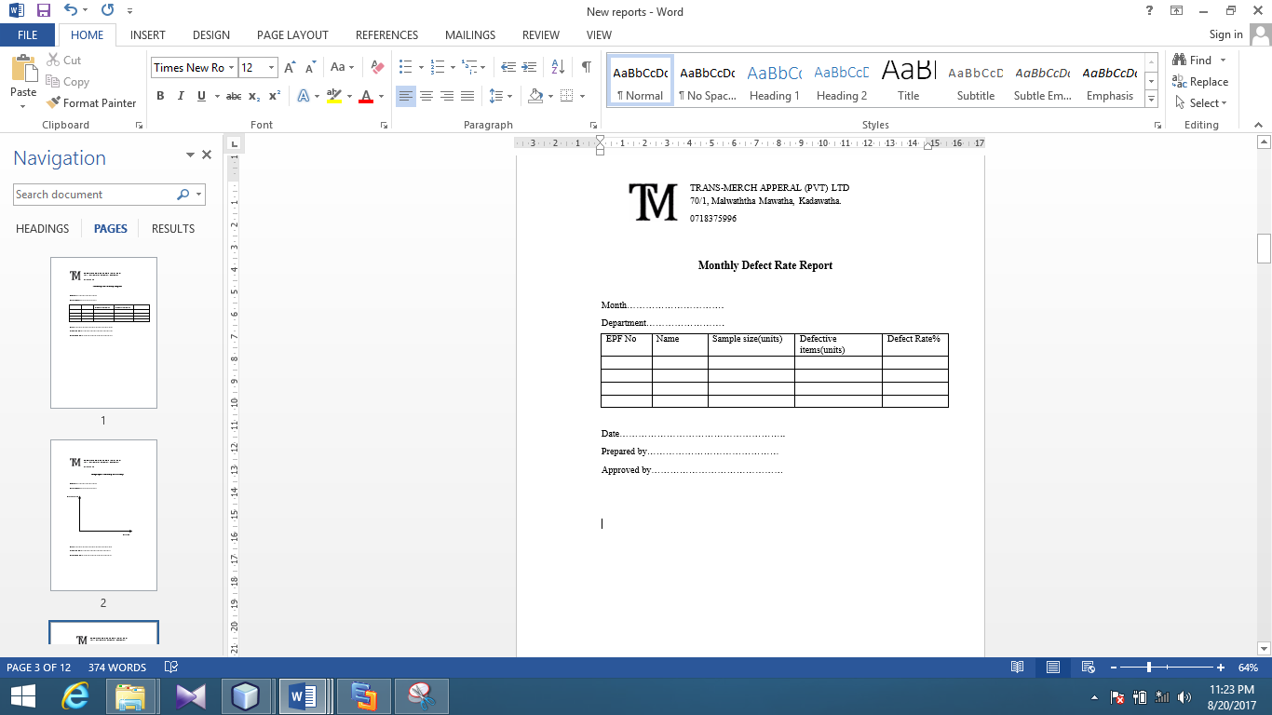

Figure : Defect Rate

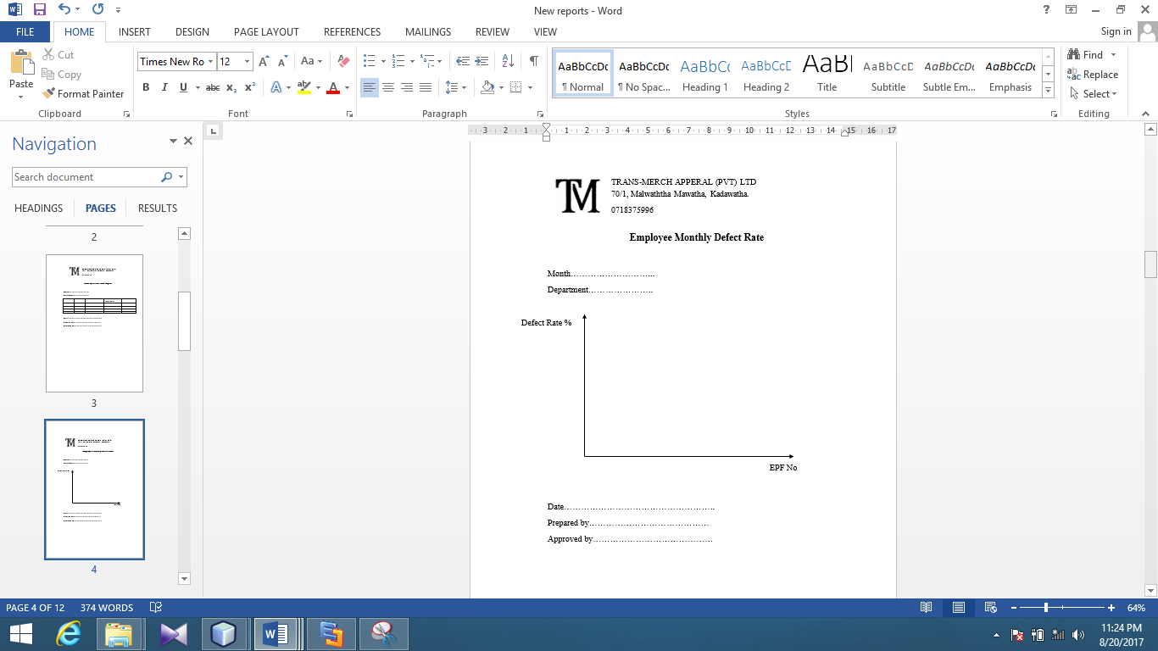

Figure : Defect Rate (Graph)

4.1.5 Employee Efficiency

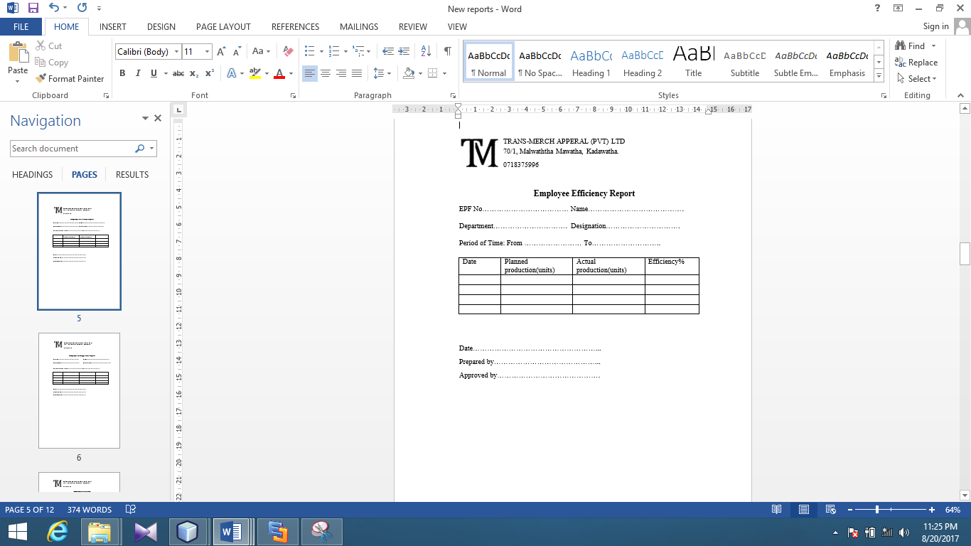

Figure : Efficiency

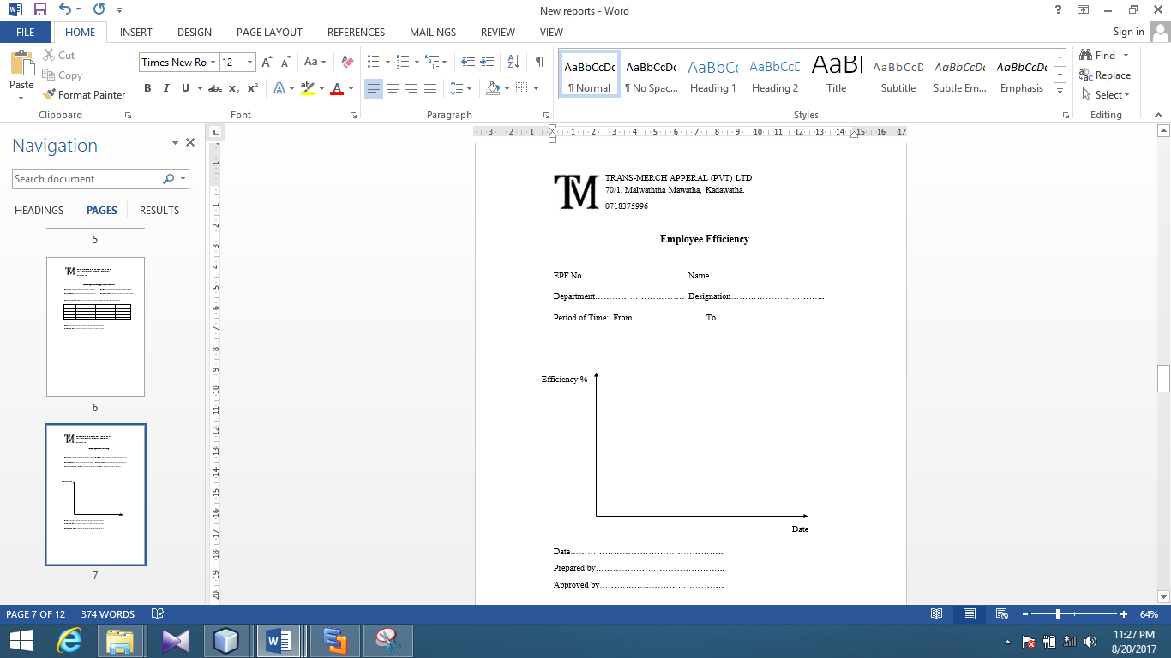

Figure : Efficiency (Graph)

## 4.2 Summarized Reports

These reports give the summary of the above detailed reports.

### 4.2.1 Attendance

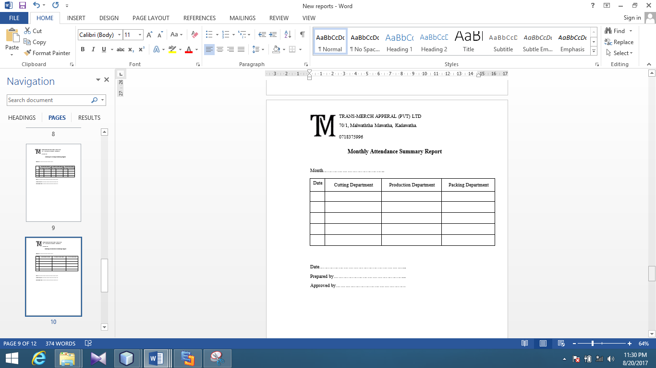

Figure : Attendance

### 4.2.2 Efficiency

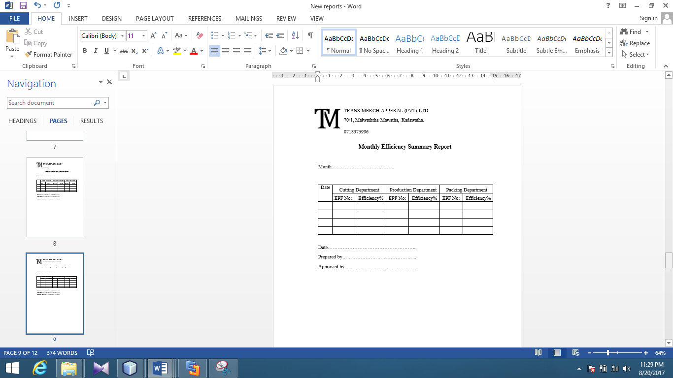

Figure : Efficiency

### 4.2.3 Damage Rate

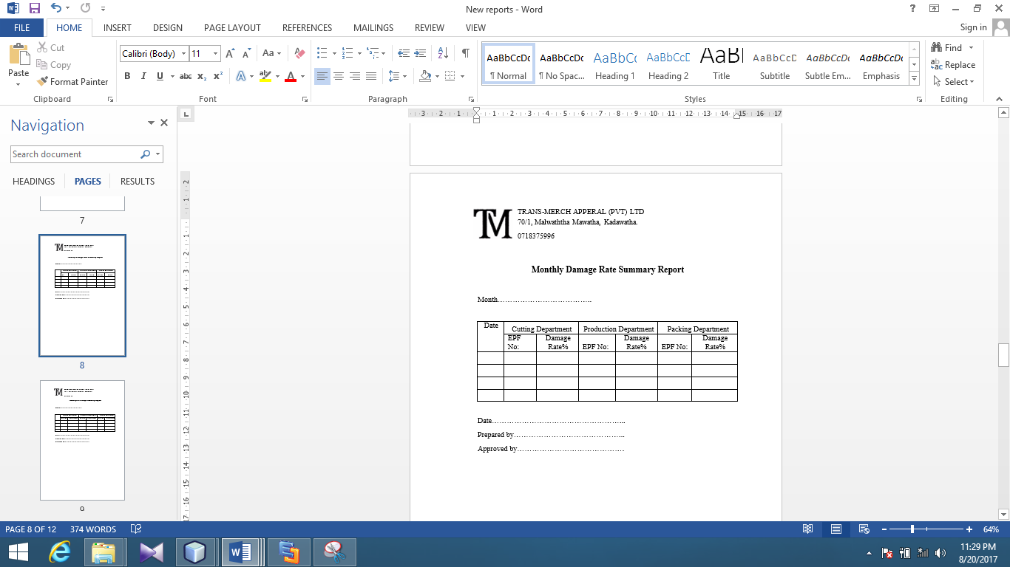

Figure : Damage Rate

### 4.2.3 Employee Performance

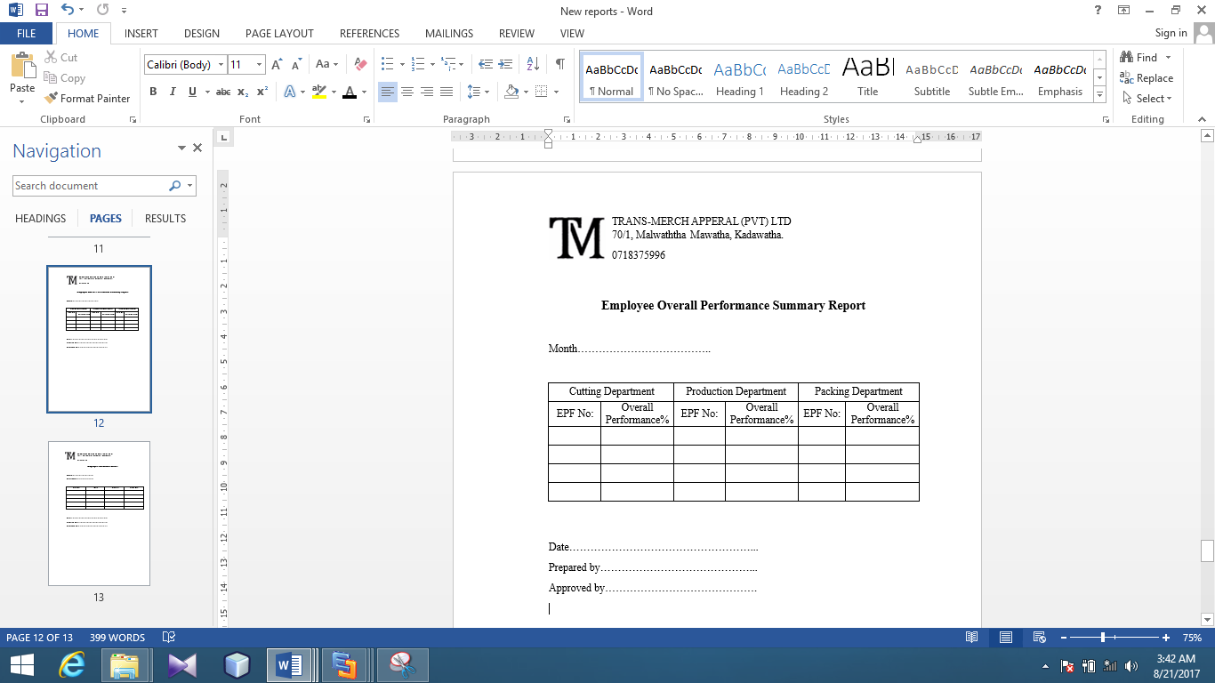

### 4***.2.4 Employee Overall Performance***

Figure : Overall Performance